## The Age of Israel

The Age of the Jews or the Age of Israel began with the Exodus of the nation of Israel from Egypt in 1441 BC and continued until the birth of Christ in 4 BC. This is the dispensation when Israel was a client nation to God and a ritual plan of God for believers.

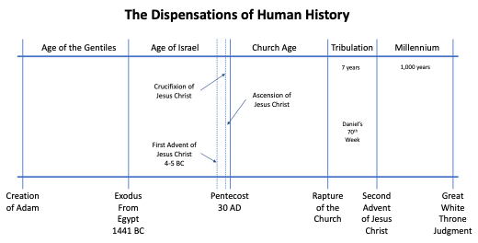

This dispensation involved rituals that illustrated the issue of payment for sin and that the Messiah would come to pay for the sins of all mankind. In this dispensation, as with all dispensations, salvation was by faith alone in Jesus Christ alone. Works of the Mosaic Law cannot ever achieve salvation. Gal. 2:16; Rom. 3:21-23.

“nevertheless knowing that a man is not justified by the works of the Law but through faith in Christ Jesus, even we have believed in Christ Jesus, so that we may be justified by faith in Christ and not by the works of the Law; since by the works of the Law no flesh will be justified.” (Galatians 2:16, NASB)

“But now apart from the Law the righteousness of God has been manifested, being witnessed by the Law and the Prophets, even the righteousness of God through faith in Jesus Christ for all those who believe; for there is no distinction; for all have sinned and fall short of the glory of God,” (Romans 3:21-23, NASB)

Salvation by faith in Christ and was illustrated by Abraham in Genesis 15:6.

“Then he believed in the LORD; and He reckoned it to him as righteousness.” (Genesis 15:6, NASB)

In the dispensation of Israel, God made four unconditional covenants with the Jews that would all be fulfilled in the future, in the Millennial reign of Christ on earth. They are the Abrahamic, Palestinian, Davidic, and New Covenants.

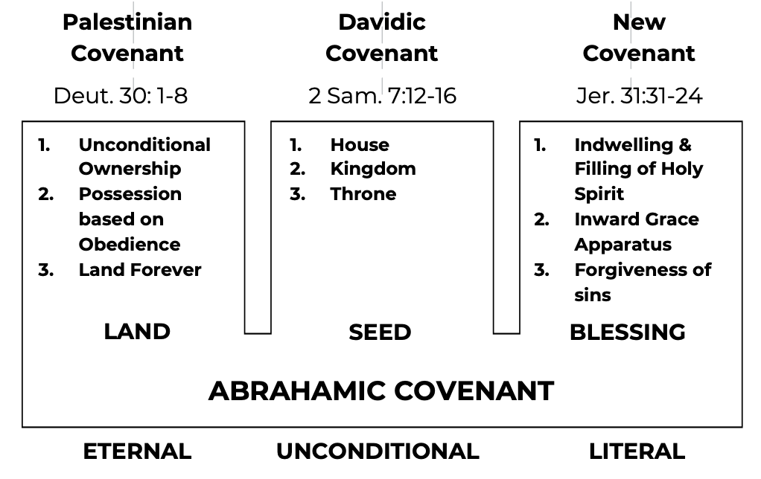

**The Abrahamic Covenant**

The Abrahamic Covenant is found in the conversation between God and Abraham in Genesis 12, 13, 15, 17, and 22. Abraham and his seed were promised land (the land of Canaan), seed (descendants), and blessing (through faith) forever if they utilize God’s grace provision. This is the basic covenant.

The Abrahamic Covenant defines the new race of Jews for the nation of Israel. Abraham became the first of a race of Jews and the first Jewish believer at age 99. His circumcision was the outward sign of his belief in the future Messiah for salvation.

The Abrahamic Covenant says that the seed of the woman, the humanity of Christ, will descend from Abraham, Isaac, and Jacob. Gen. 12:1-3; Gen. 13:15-16; Gen. 15:18; Gen. 22:15-18; Gen. 26:3-4; Exodus 6:2-8. See category on the Abrahamic Covenant.

"Now the LORD said to Abram, "Go forth from your country, And from your relatives And from your father's house, To the land which I will show you; And I will make you a great nation, And I will bless you, And make your name great; And so you shall be a blessing; And I will bless those who bless you, And the one who curses you I will curse. And in you all the families of the earth will be blessed."" (Genesis 12:1-3, NASB)

"for all the land which you see, I will give it to you and to your descendants forever. "I will make your descendants as the dust of the earth, so that if anyone can number the dust of the earth, then your descendants can also be numbered." (Genesis 13:15-16, NASB)

"On that day the LORD made a covenant with Abram, saying, "To your descendants I have given this land, From the river of Egypt as far as the great river, the river Euphrates:" (Genesis 15:18, NASB)

“"Sojourn in this land and I will be with you and bless you, for to you and to your descendants I will give all these lands, and I will establish the oath which I swore to your father Abraham. "I will multiply your descendants as the stars of heaven, and will give your descendants all these lands; and by your descendants all the nations of the earth shall be blessed;” (Genesis 26:3-4, NASB)

**The Palestinian or Land Covenant**

The Palestinian or Land Covenant is based on the Abrahamic Covenant and amplifies the land promises. Israel’s ownership of the land is unconditional, but possession is based upon obedience to the plan of salvation and spiritual growth in grace. Deut. 30:1-8; Gen. 15:18; Joshua 1:3-4; Num. 34:1-12. See category on The Palestinian or Land Covenant.

"On that day the LORD made a covenant with Abram, saying, "To your descendants I have given this land, From the river of Egypt as far as the great river, the river Euphrates:" (Genesis 15:18, NASB)

""Every place on which the sole of your foot treads, I have given it to you, just as I spoke to Moses. "From the wilderness and this Lebanon, even as far as the great river, the river Euphrates, all the land of the Hittites, and as far as the Great Sea toward the setting of the sun will be your territory." (Joshua 1:3-4, NASB)

**The Davidic Covenant**

The Davidic Covenant amplifies the seed promises of the Abrahamic Covenant. Among the seed (descendants of Abraham) would be the humanity of the God-man Jesus Christ (the seed of the woman of Genesis 3:15) who would descend from the tribe of Judah through the family of David and become the Savior of mankind. 2 Sam. 7:12-16; Psalms 89:20-37. See category on The Davidic Covenant.

““When your days are complete and you lie down with your fathers, I will raise up your descendant after you, who will come forth from you, and I will establish his kingdom. “He shall build a house for My name, and I will establish the throne of his kingdom forever. “I will be a father to him and he will be a son to Me; when he commits iniquity, I will correct him with the rod of men and the strokes of the sons of men, but My lovingkindness shall not depart from him, as I took it away from Saul, whom I removed from before you. “Your house and your kingdom shall endure before Me forever; your throne shall be established forever.”‘““  (2 Samuel 7:12-16, NASB)

"And I will put enmity Between you and the woman, And between your seed and her seed; He shall bruise you on the head, And you shall bruise him on the heel."" (Genesis 3:15, NASB)

**The New Covenant**

The New Covenant promises the restoration of the nation of Israel (only regenerate Jews) at the Second Advent of Jesus Christ. The restored nation of Israel will exist in the Millennium. The New Covenant amplifies the blessing promises of the Abrahamic Covenant. It provided for conversion through the blood of the everlasting covenant and soul grace apparatus. Jer. 31:31-34; Rom. 11:27; Gal. 4:4; Heb. 8:8-12; Heb. 10:15-17.

““Behold, days are coming,” declares the LORD, “when I will make a new covenant with the house of Israel and with the house of Judah, not like the covenant which I made with their fathers in the day I took them by the hand to bring them out of the land of Egypt, My covenant which they broke, although I was a husband to them,” declares the LORD. “But this is the covenant which I will make with the house of Israel after those days,” declares the LORD, “I will put My law within them and on their heart I will write it; and I will be their God, and they shall be My people. “They will not teach again, each man his neighbor and each man his brother, saying, ‘Know the LORD,’ for they will all know Me, from the least of them to the greatest of them,” declares the LORD, “for I will forgive their iniquity, and their sin I will remember no more.”“  (Jeremiah 31:31-34, NASB)

"But when the fullness of the time came, God sent forth His Son, born of a woman, born under the Law," (Galatians 4:4, NASB)

“And the Holy Spirit also testifies to us; for after saying, "THIS IS THE COVENANT THAT I WILL MAKE WITH THEM AFTER THOSE DAYS, SAYS THE LORD: I WILL PUT MY LAWS UPON THEIR HEART, AND ON THEIR MIND I WILL WRITE THEM," He then says, "AND THEIR SINS AND THEIR LAWLESS DEEDS I WILL REMEMBER NO MORE."” (Hebrews 10:15-17, NASB)

The “seed of the woman,” the humanity of Christ, will return to the earth at the Second Advent to restore the nation of Israel. Our Lord will rule and bless the nation of Israel throughout the Millennium. See category on The New Covenant to Israel.

**The Old Covenant or Mosaic Law**

The Mosaic Law is God’s covenant to Israel that defines God’s spiritual and governing policy for the nation of Israel. It is the only conditional covenant to Israel and involves believers and unbelievers. The Mosaic Law contains God’s statutes and ordinances and laws that address every aspect of life in the nation of Israel including legal freedoms, the laws and functions of divine establishment, and the functions of the spiritual life for believers in Israel. Exodus 19:3; Lev. 26:46; Rom. 3:19; Rom. 9:4. See the category on The Mosaic Law.

"Moses went up to God, and the LORD called to him from the mountain, saying, "Thus you shall say to the house of Jacob and tell the sons of Israel:" (Exodus 19:3, NASB)

"These are the statutes and ordinances and laws which the LORD established between Himself and the sons of Israel through Moses at Mount Sinai." (Leviticus 26:46, NASB)

"Now we know that whatever the Law says, it speaks to those who are under the Law, so that every mouth may be closed and all the world may become accountable to God;" (Romans 3:19, NASB)

"who are Israelites, to whom belongs the adoption as sons, and the glory and the covenants and the giving of the Law and the temple service and the promises," (Romans 9:4, NASB)

**The Five Jewish Client Nations to God**

The first Jewish client nation to God was the Theocratic Kingdom that lasted from the Exodus from Egypt in 1441 BC to the time of Samuel at about 1020 BC. This was the time when the Son of God directly ruled Israel.

The second Jewish client nation to God was the United Kingdom that started with Saul in 1020 BC and lasted until the time of Rehoboam in 926 BC.

The third Jewish client nation to God was the Northern Kingdom that extended from Jeroboam in 926 BC to Hoshea in 721 BC. It was completely destroyed as a client nation when conquered by the Assyrians in 721 BC. God used the Assyrians to administer the fifth cycle of divine discipline to the nation.

The fourth Jewish client nation to God was the Southern Kingdom (Judah) that lasted from the time of Rehoboam in 926 BC to the time of Zedekiah in 586 BC. The Southern Kingdom also was conquered by Nebuchadnezzar and the Chaldean army who was used by God to administer the fifth cycle of discipline to that nation. The nation of Israel remained captive for 70 years.

The fifth Jewish client nation to God was the restored nation of Judea from the time of Zerubbabel in 536 BC to 63 BC when Pompey the Great captured Jerusalem and desecrated the Temple. From 63 BC to 70 AD, Judea still existed as a nation, but not a client nation to God. In 70 AD, the nation was finally destroyed by Rome.

Judea remained as a national entity to provide the Jews an opportunity to make a decision about the Lord Jesus Christ as the Messiah during His Incarnation. They received warnings and signs (including the functions of tongues) for 40 more years as special evangelism warning to them that their destruction from God's divine discipline was imminent. They continued to reject Jesus Christ as their Messiah. As a result, Jerusalem was completely destroyed in 70 AD and all surviving Jews went into slavery. Isaiah 28:11; 1 Cor. 14:21-22.

“Indeed, He will speak to this people Through stammering lips and a foreign tongue,” (Isaiah 28:11, NASB)

“In the Law it is written, "BY MEN OF STRANGE TONGUES AND BY THE LIPS OF STRANGERS I WILL SPEAK TO THIS PEOPLE, AND EVEN SO THEY WILL NOT LISTEN TO ME," says the Lord. So then tongues are for a sign, not to those who believe but to unbelievers; but prophecy is for a sign, not to unbelievers but to those who believe.” (1 Corinthians 14:21-22, NASB)

From 70 AD onward, only Gentile nations will function as client nations. A client nation must have freedom and must use its freedom to promote evangelism within the nation, to teach the Word of God, and to support missionary activity outside the nation.

At the Second Advent, Israel will be regathered and restored as a client nation that will last throughout the Millennium. This future fulfillment is guaranteed to Jewish believers only.